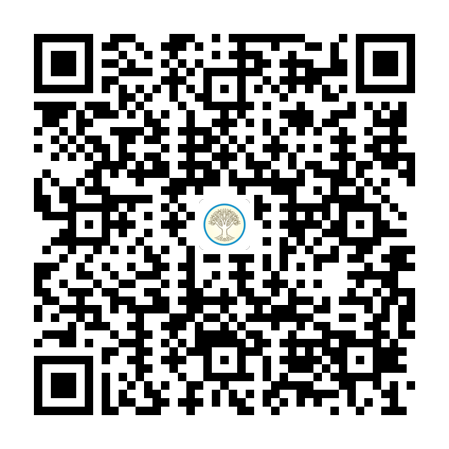

An announcement has been added in the "CS522-2017-05A-05D" site at (<https://online.cs.mum.edu/portal/site/e8f8d466-d00b-4d2d-85a5-b4e3aadb3ebe>) at May 11, 2017 7:05 am

Dear Students,

Make sure to download the MUM app right away. Here is a [short video](https://www.youtube.com/watch?v=CajLsSAbavE&feature=youtu.be) showing the useful features of the MUM app. Visit[www.mum.campusapp.com](http://www.mum.campusapp.com/) to download the app.

On May 5th, we will all check into class using the Scan-in feature of the app. So please download the app right away. The video above gives a brief explanation of the Scan feature at :45 seconds.

Make sure you activate your [mum.edu](http://mum.edu/) emails before class on May 1st. We will only be using those emails to communicate with you during the course.